

**DIGITAL ASSIGNMENT 3**

**NAME: AYUSH SHARMA**

**REGISTER NUMBER: 21BDS0058**

**COURSE CODE: BCSE302P**

**COURSE NAME: DATABASE SYSTEM LAB**

# Exercise 1:

**Question 1:** Write a PL/SQL block to accept an emp_no and display the salary of the person.

# SQL Command:

declare

v_SSN Employee.SSN_Number%type; v_Salary Employee.Salary%type; begin

v_SSN := '&v_SSN';

select Salary into v_Salary from Employee where SSN_Number = v_SSN;

dbms_output.put_line(v_Salary); end;

# Output:

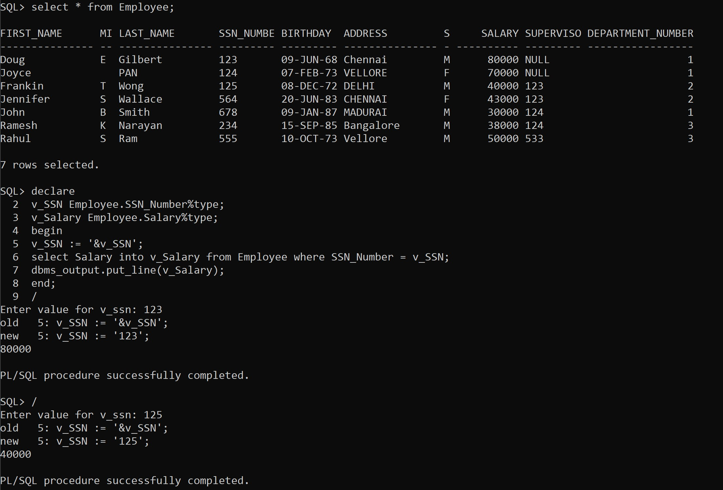

**Question 2:** Write a PL/SQL program to delete one record in employee table

# SQL Command:

declare

v_name Employee.First_Name%type; begin

v_name:= '&v_name';

delete from Employee where First_Name = v_name; dbms_output.put_line('Record Deleted');

end;

# Output:

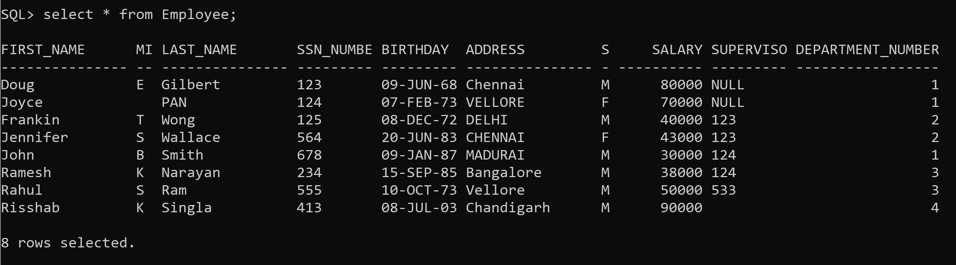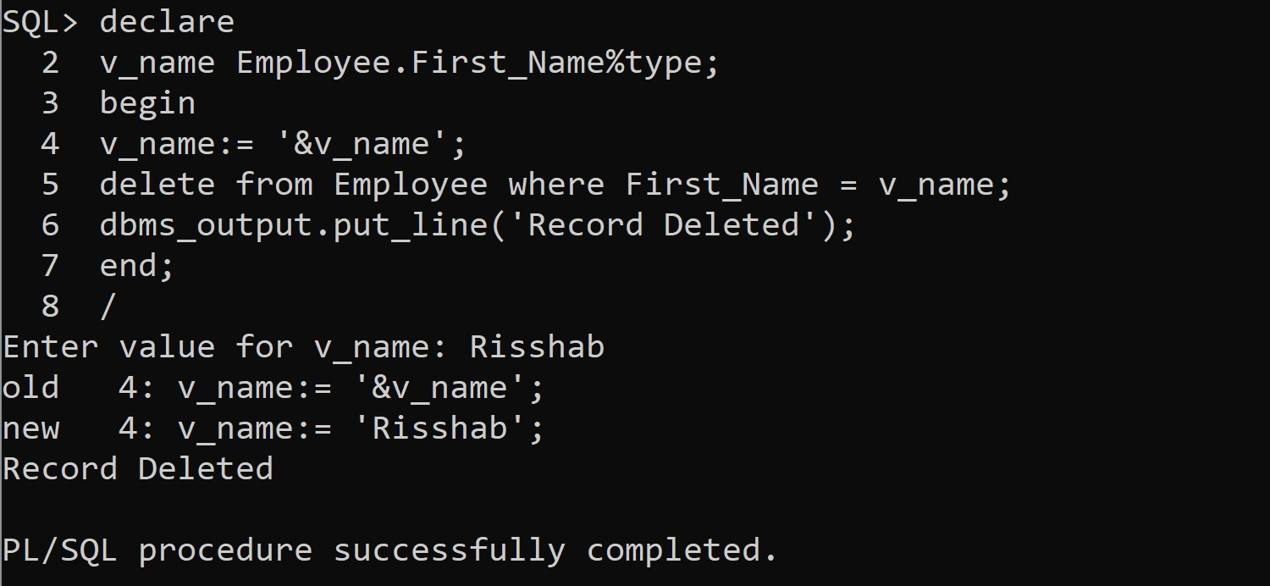

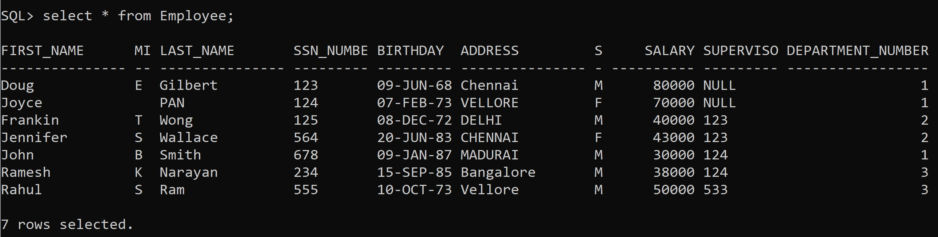

**Question 3**: Write a PL/SQL program to display the avg salary of all employees

# SQL Command:

declare

v_avg_sal number(7,2);

Begin

select avg(Salary) into v_avg_sal from Employee; dbms_output.put_line(v_avg_sal);

end;

# Output:

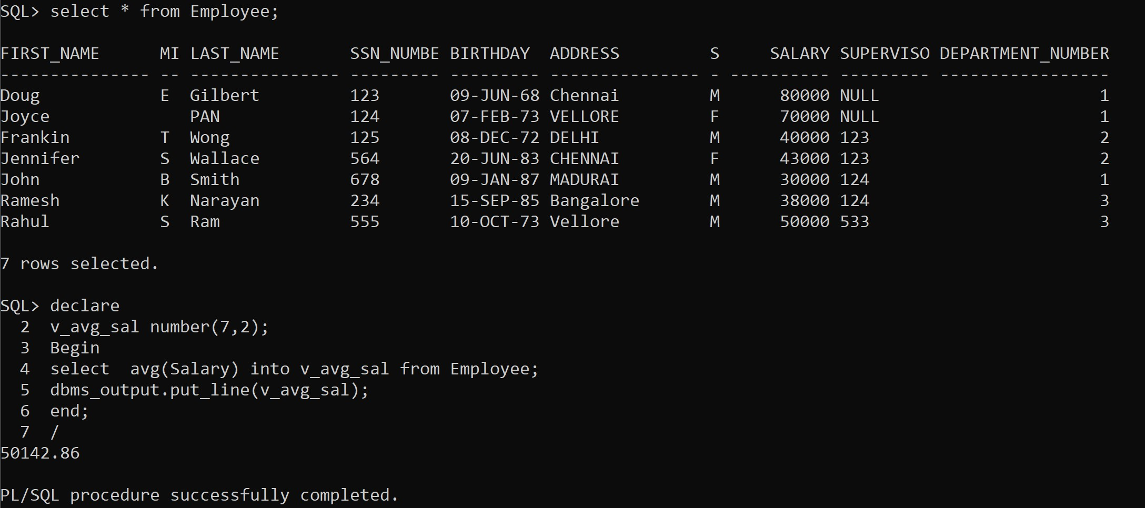

**Question 4**: Write a PL/SQL program to insert a new employee in the employee table.

# SQL Command:

declare begin

insert into Employee (First_Name, Mid_Name, Last_Name, SSN_Number, Birthday, Address, Sex, Salary, Supervisor_SSN, Department_Number) values ('&First_Name' , '&Mid_Name' , '&Last_Name' , &SSN_Number , '&Birthday' , '&Address' , '&Sex' , &Salary , &Supervisor_SSN , &Department_Number ); dbms_output.put_line ('Record Inserted');

end;

# Output:

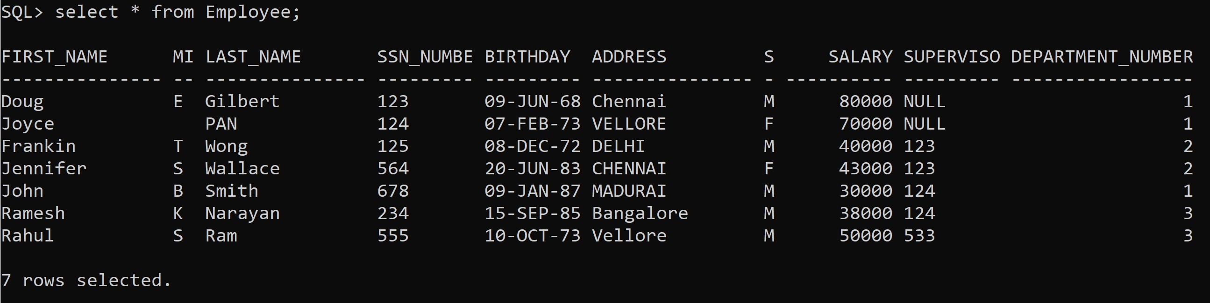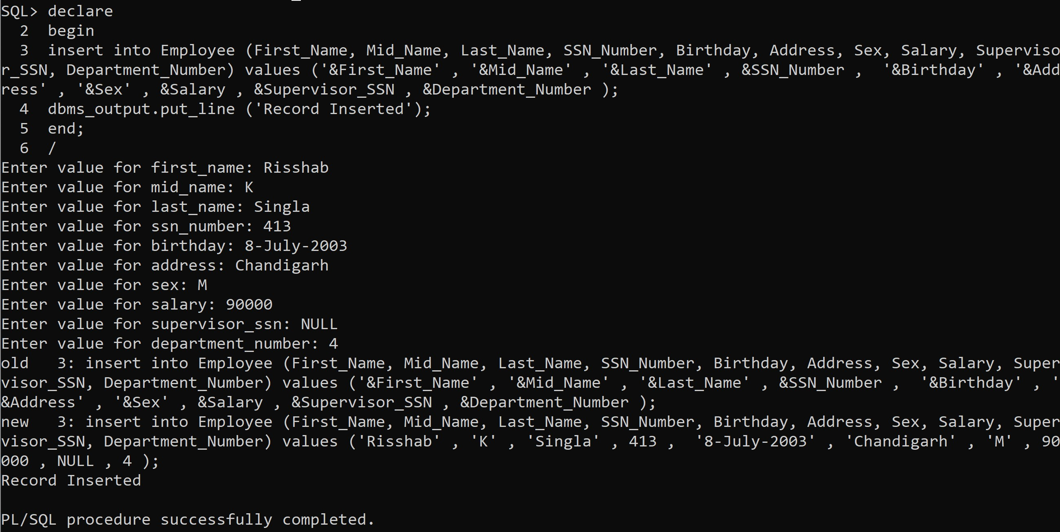



**Question 5**: Write a PL/SQL program to increment of salary belongs to department 1 as 10%.

# SQL Command:

declare begin

update Employee set Salary = Salary * 1.1 where Department_Number = 1; dbms_output.put_line( 'Record Updated') ;

end;

# Output:

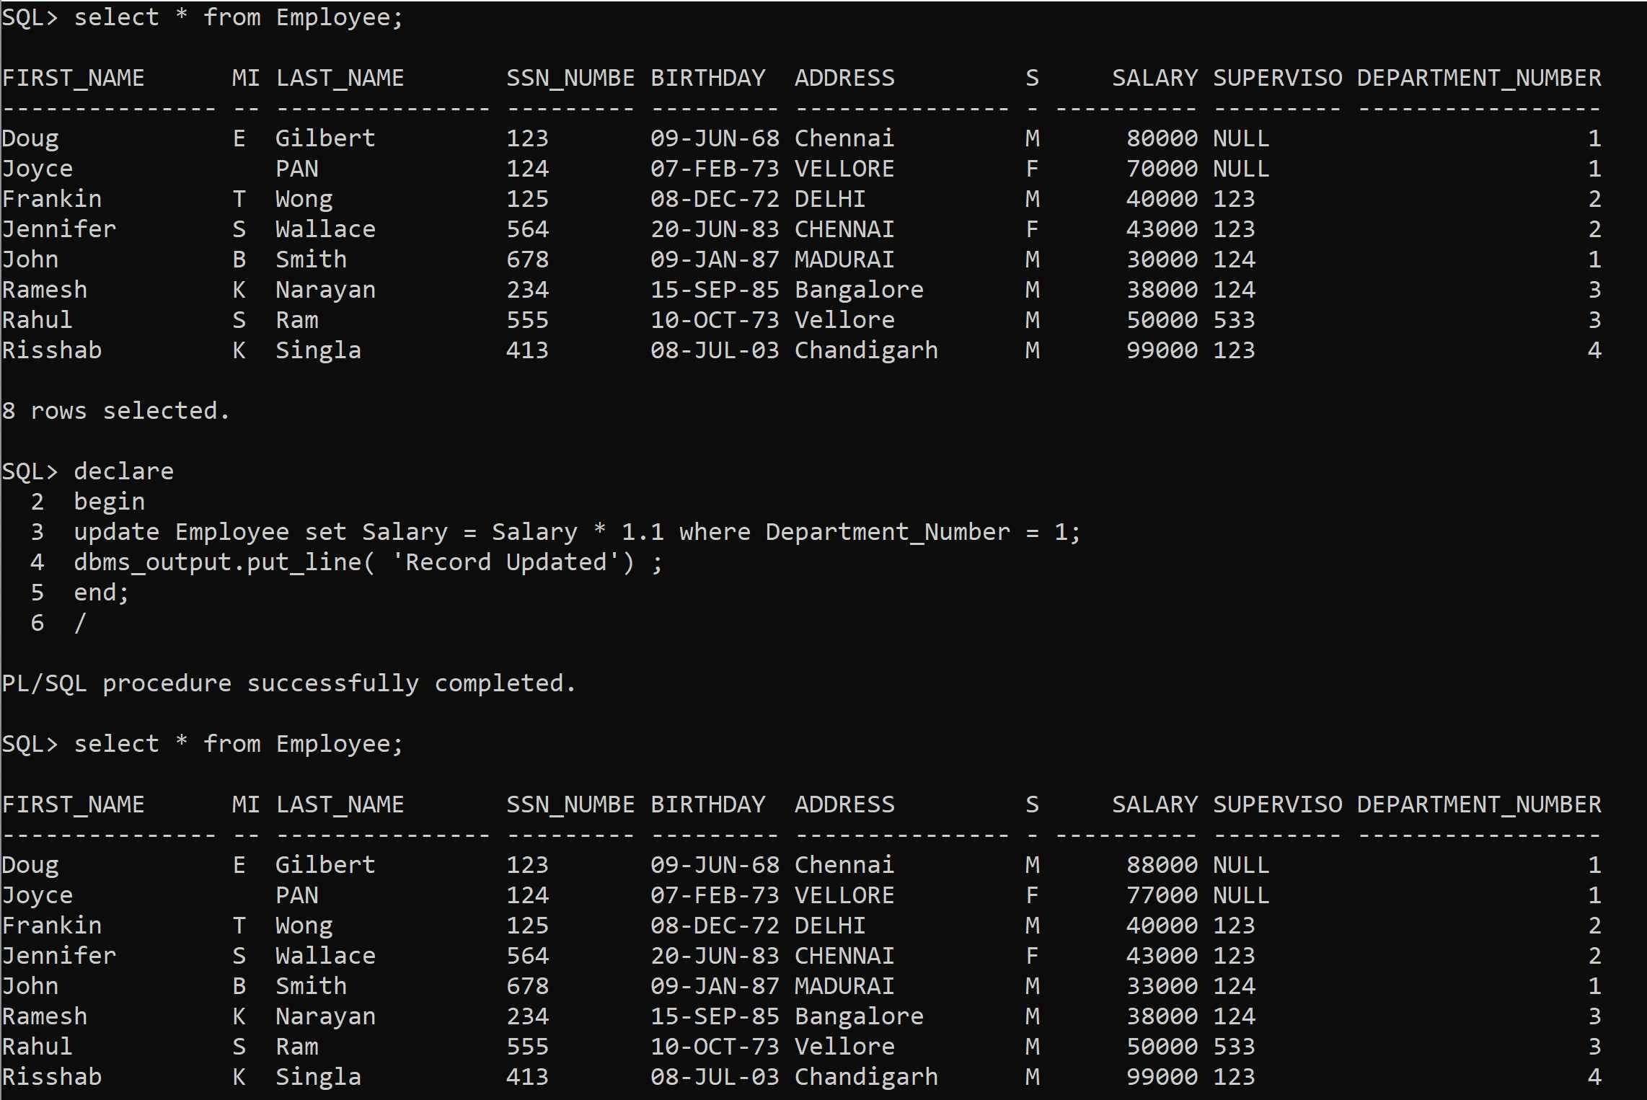

**Exercise 2:**

**Question 1:** Write a PL/SQL block to find the whether a given number is odd or even.

# SQL Command:

declare

num number; remainder number; begin

num:= &num;

remainder := MOD(num,2); if remainder = 0 then

dbms_output.put_line('Even'); else dbms_output.put_line('Odd'); end if;

end;

# Output:

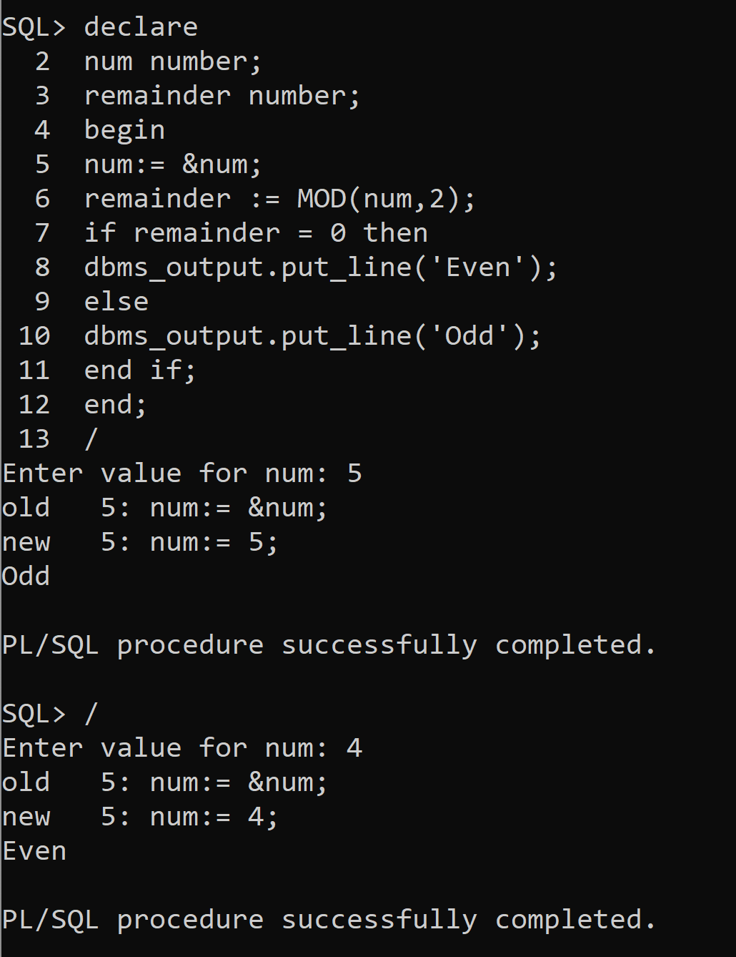

**Question 2:** Write a PL/SQL code as menu driven to perform arithmetic operations. (use: case selector )

# SQL Command:

declare

choice number; num1 number; num2 number; num3 number; begin

dbms_output.put_line('Enter the first number'); num1 := &num1;

dbms_output.put_line('Enter the second number'); num2 := &num2;

dbms_output.put_line('Enter 1 for addition, 2 for subtraction, 3 for multiplication, 4 for division, 5 for remainder');

choice := & choice; case choice

when 1 then

num3 := num1 + num2;

dbms_output.put_line('The answer of addition is ' || num3); when 2 then

num3 := num1 - num2;

dbms_output.put_line('The answer of subtraction is ' || num3); when 3 then

num3 := num1 * num2;

dbms_output.put_line('The answer of multiplication is ' || num3); when 4 then

num3 := num1 / num2;

dbms_output.put_line('The answer of division is ' || num3); when 5 then

num3 := MOD(num1, num2);

dbms_output.put_line('The answer of remainder is ' || num3); else dbms_output.put_line('Invalid choice');

end case; end;

# Output:

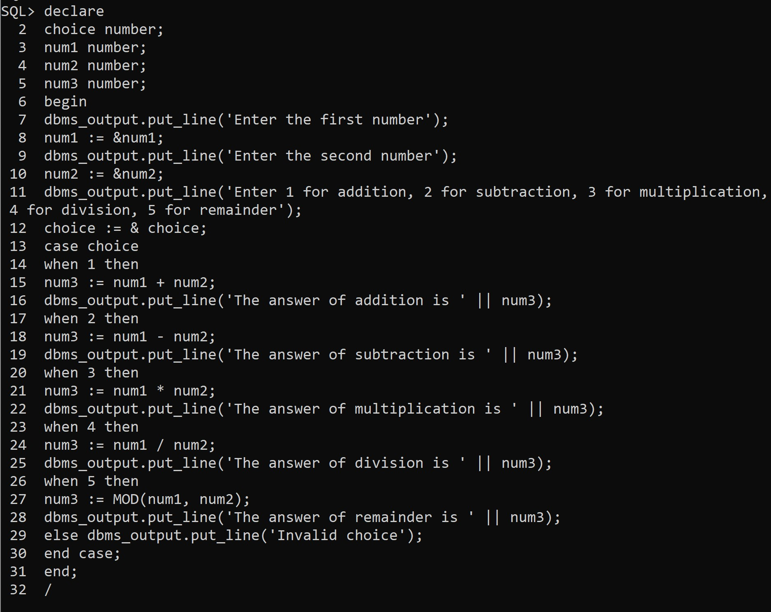

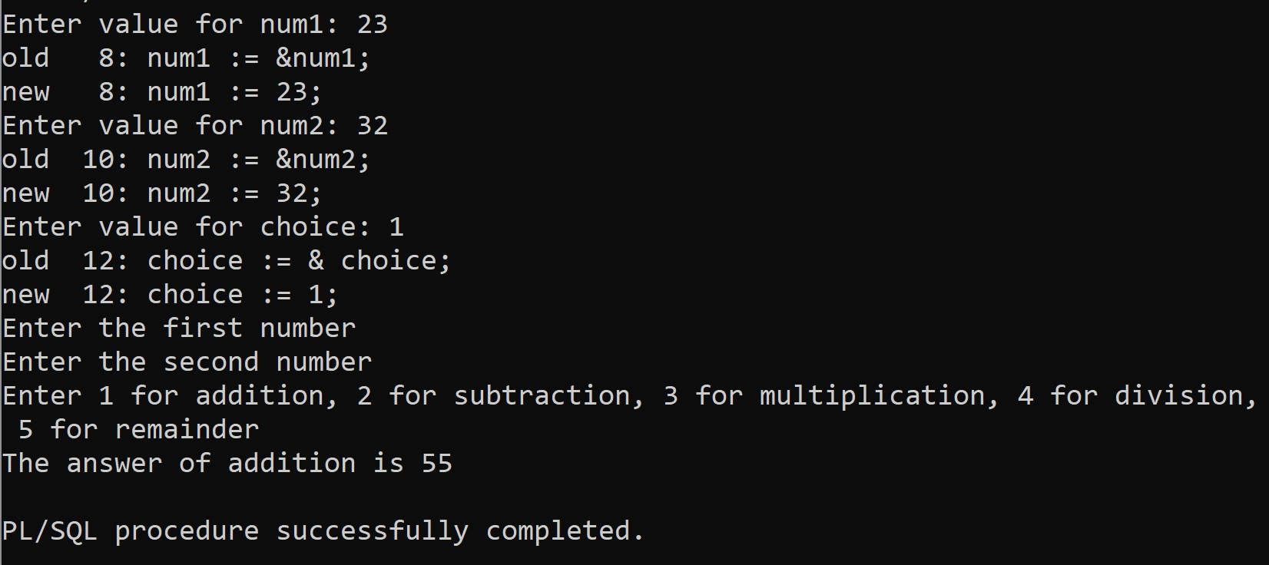

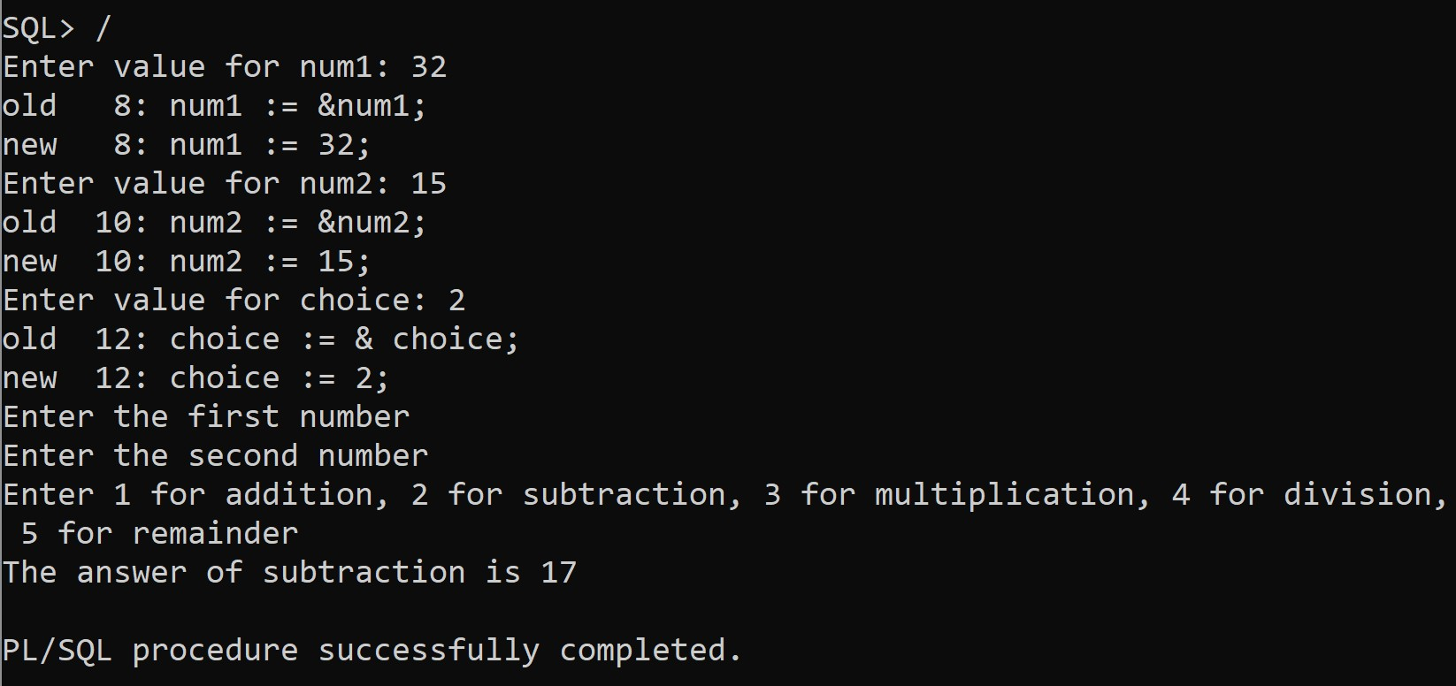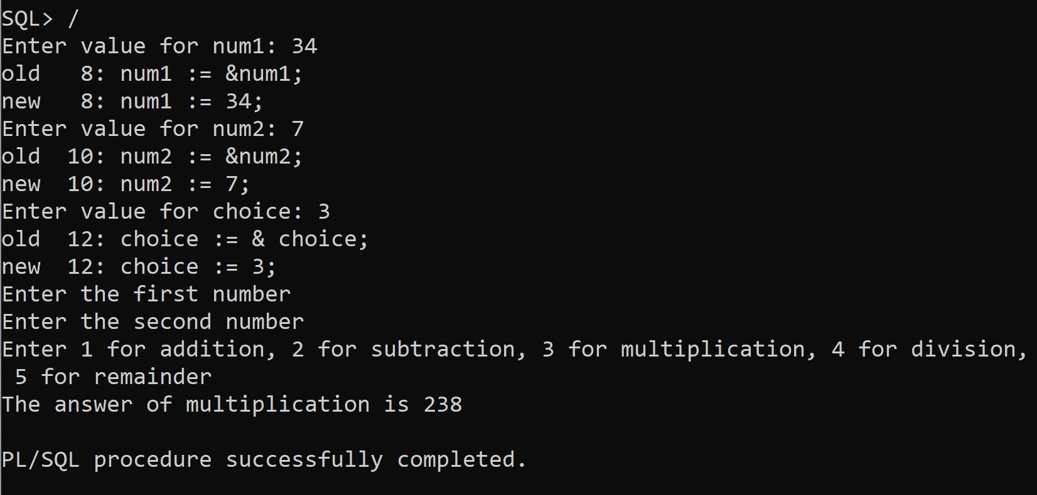

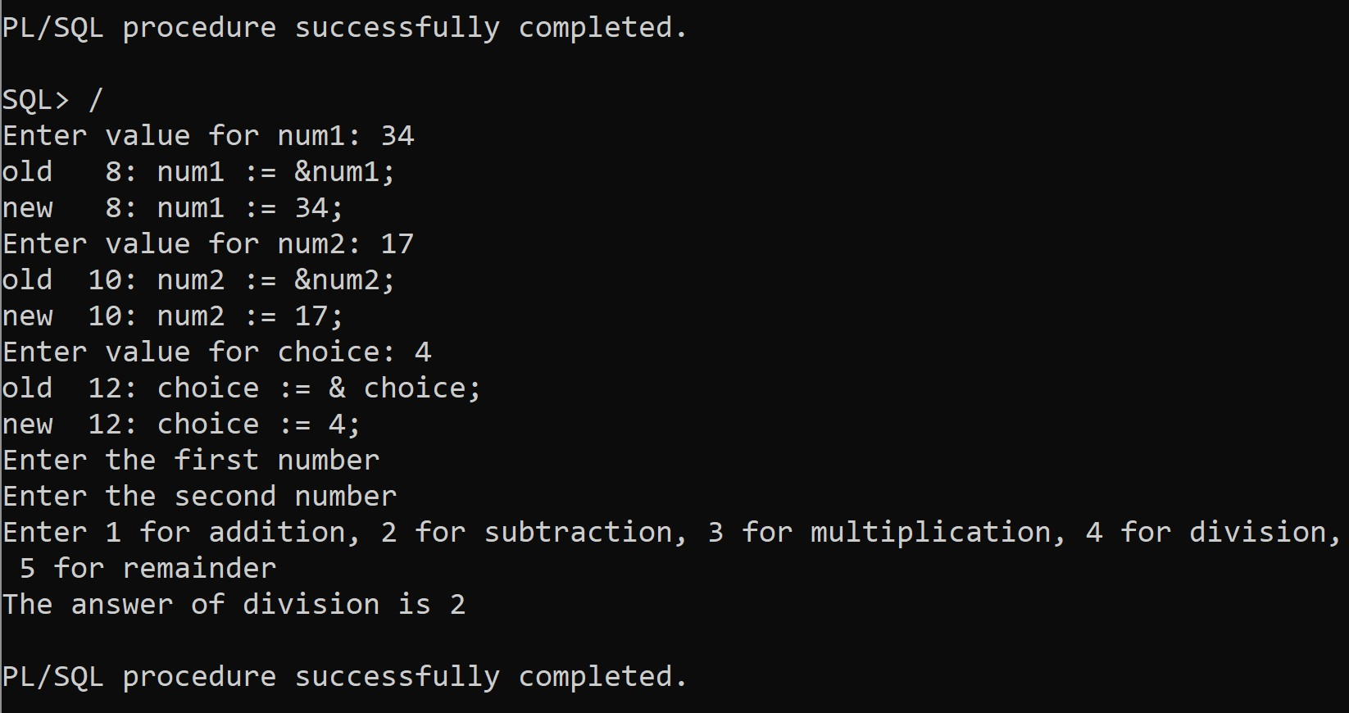

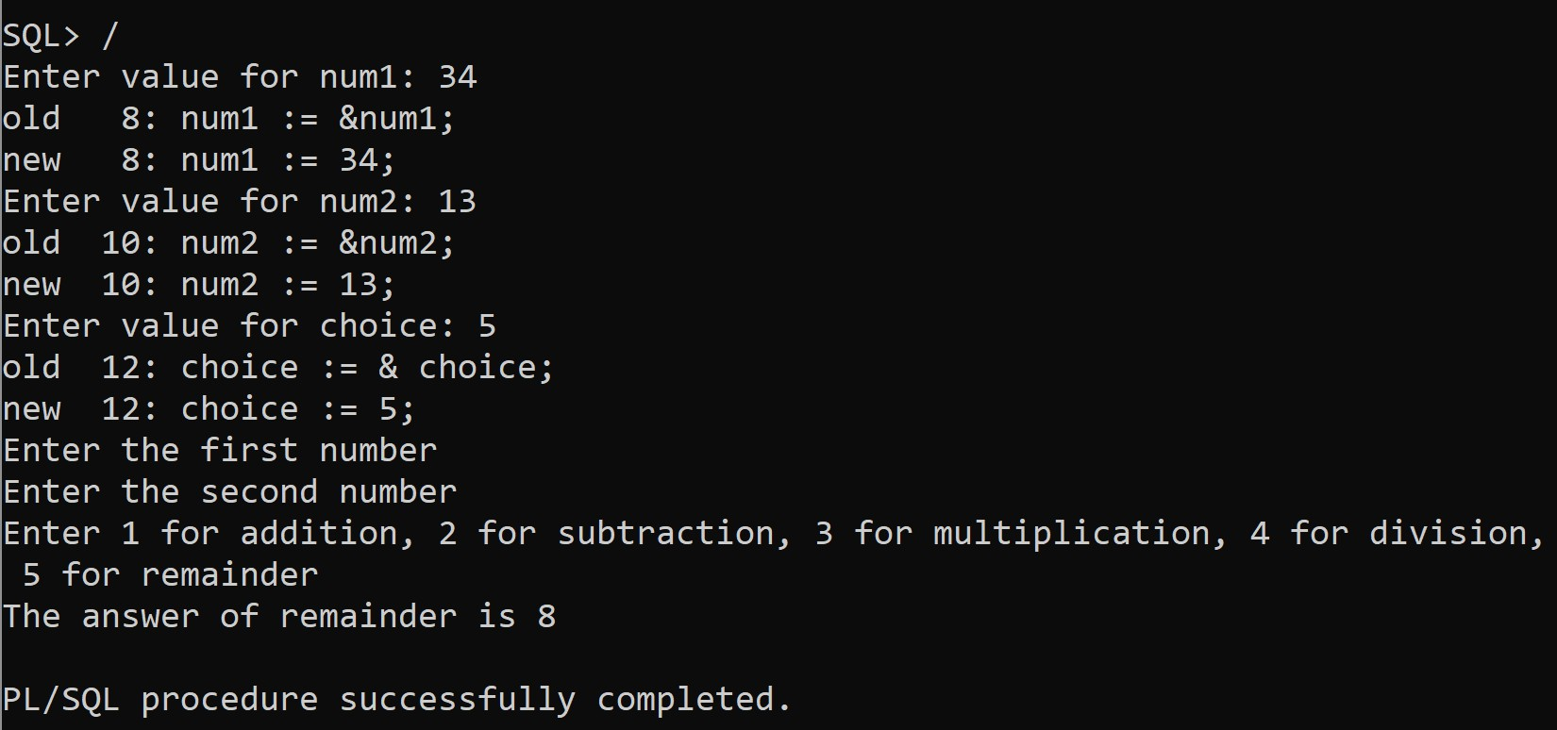

**Question 3:** Write a PL/SQL to find the factorial of the given number using function.

# SQL Command:

declare

num1 number;

itr number := 1; ans number:= 1; begin

num1 := &num1;

dbms_output.put_line('Finding the factorial of ' || num1); while itr <=num1

loop

ans := ans * itr; itr := itr+1;

end loop;

dbms_output.put_line('Factorial is: ' || ans); end;

# Output:

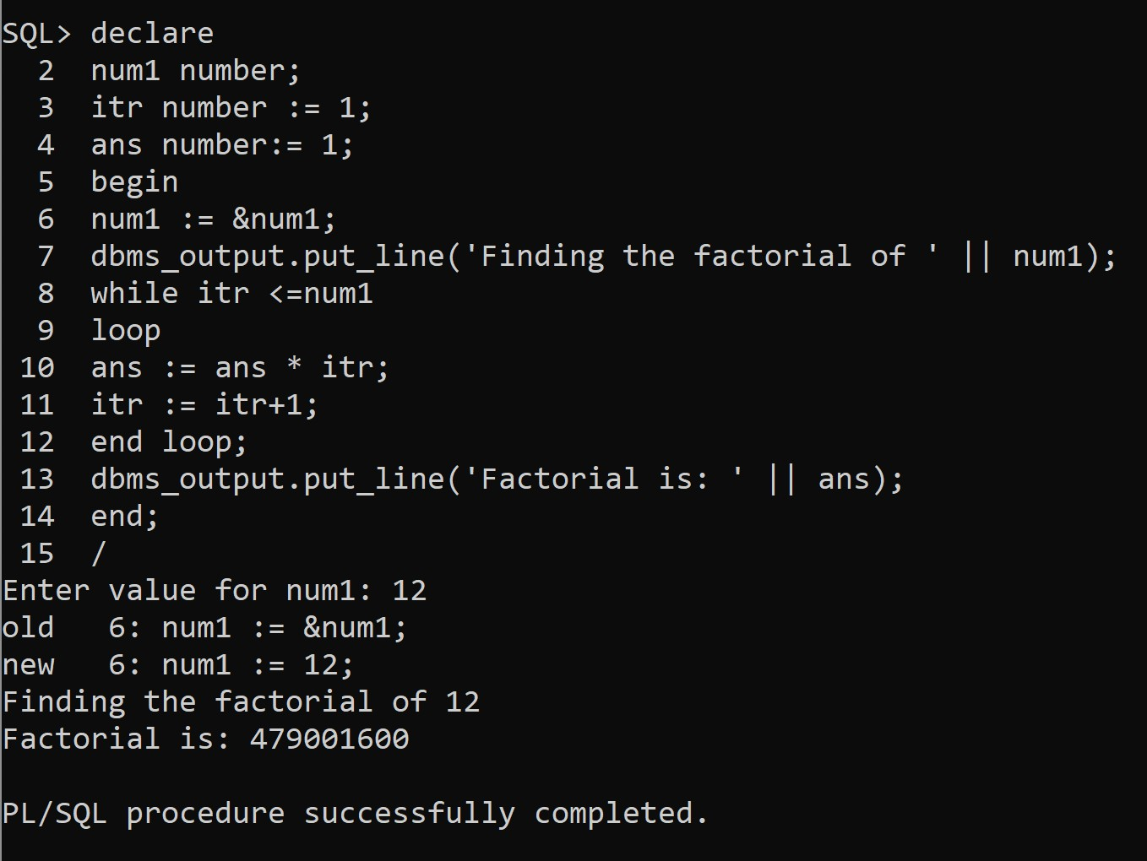

**Question 4:** Write a PL/SQL to display Fibonacci Series for the given number

# SQL Command:

declare

nums number; num1 number := 1; num2 number := 1; num3 number; begin

dbms_output.put_line('Enter the number of fibonacci numbers to print');

nums := & nums; if nums > 1 then

dbms_output.put_line(num1); nums := nums -1;

end if;

if nums > 2 then dbms_output.put_line(num2); nums := nums -1;

end if;

while nums > 0 loop

num3 := num1 + num2; dbms_output.put_line(num3); num1 := num2;

num2 := num3; nums := nums -1; end loop;

end;

# Output:

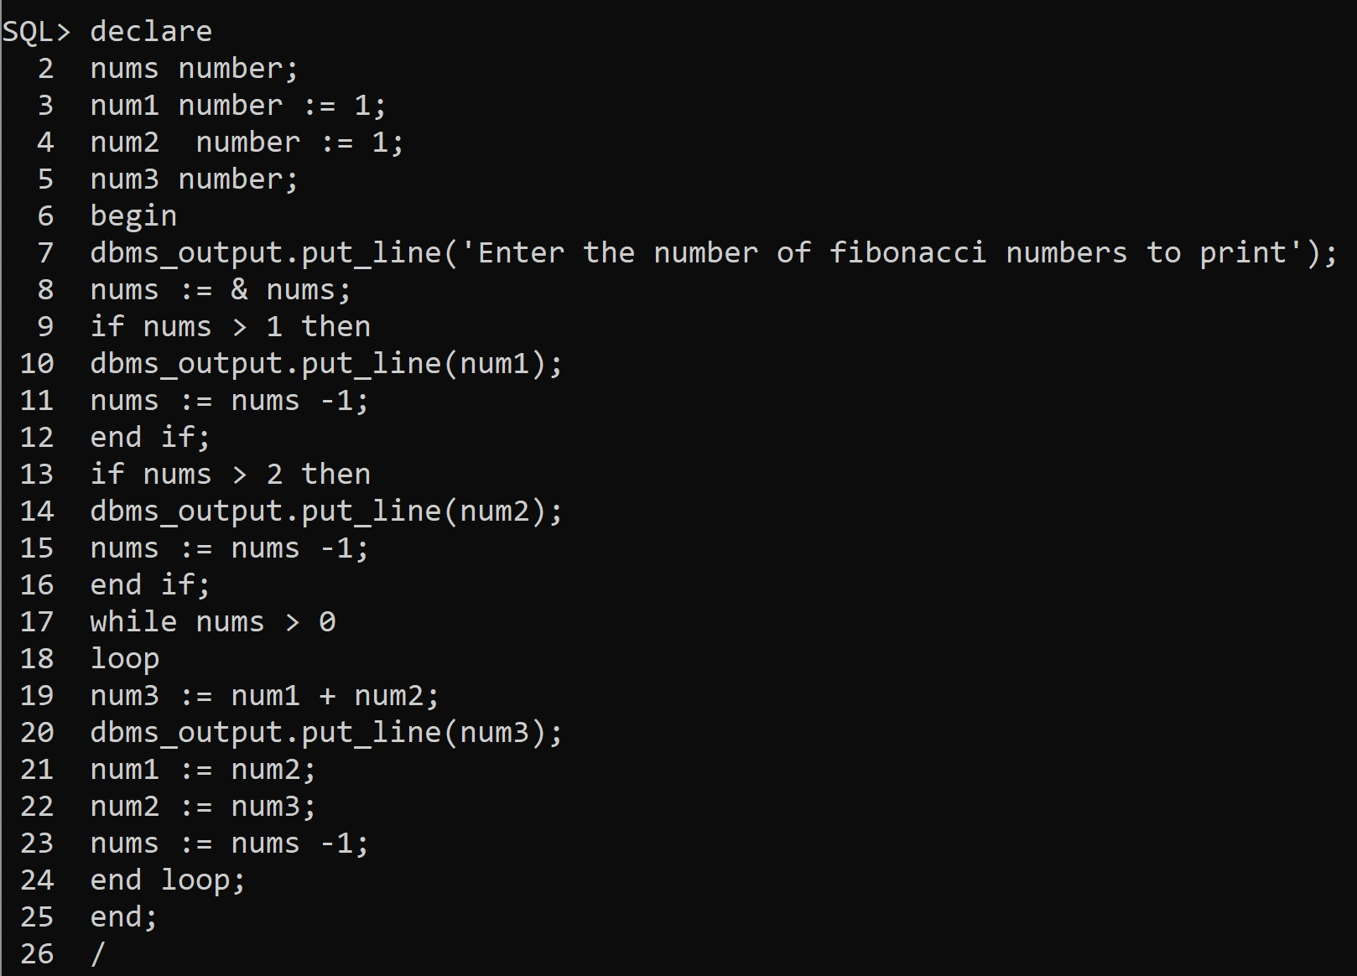

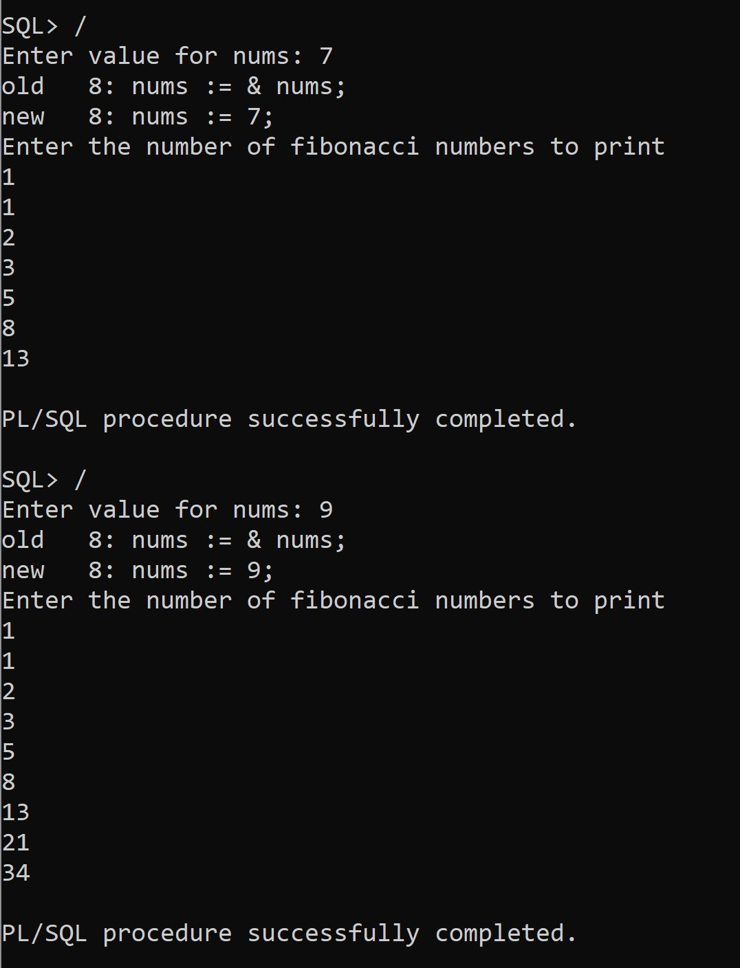

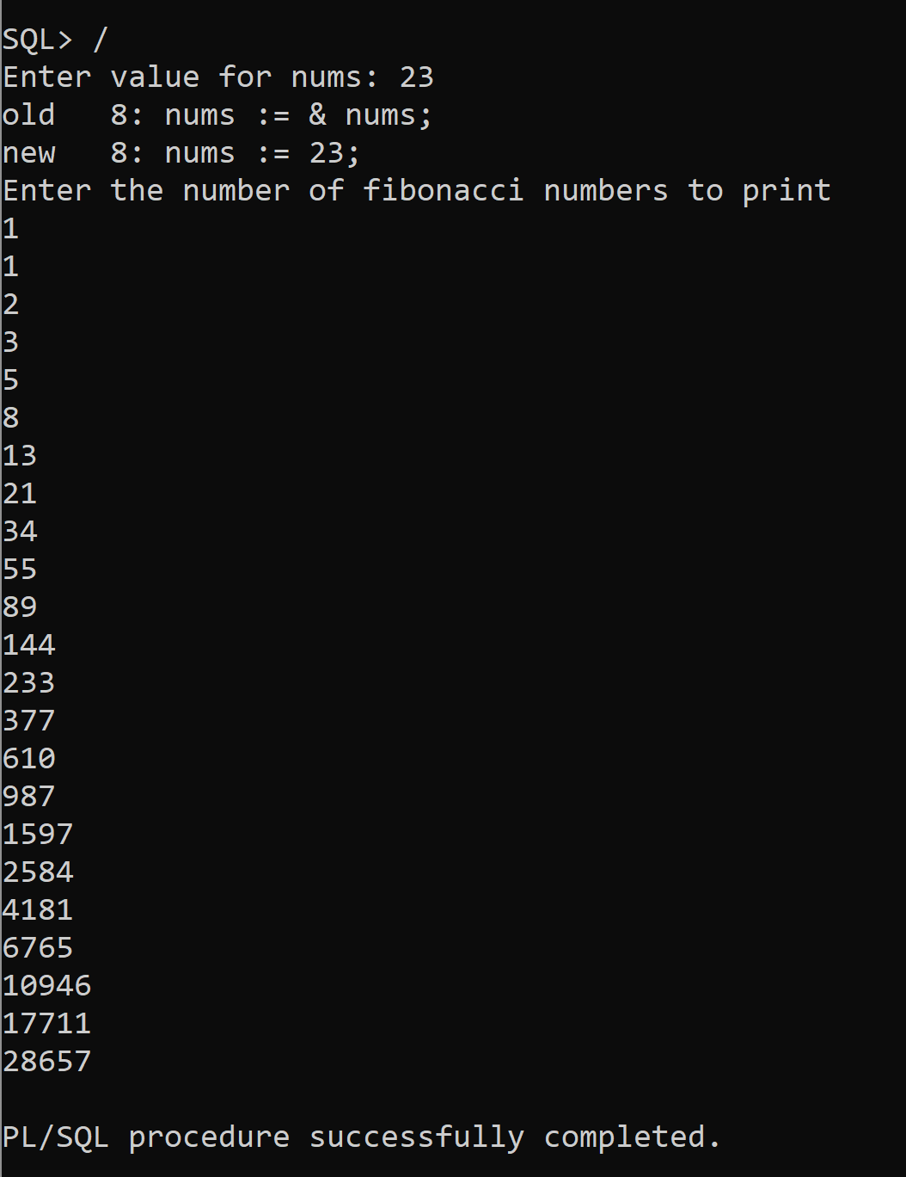

**Question 5:** Write a PL/SQL to display the reverse of number between 1 and 100.

# SQL Command:

declare

num number := 1; rev number := 0; temp number:= 1; begin

while num<=100 loop

temp := num; rev:= 0;

while temp > 0 loop

rev := (rev*10) + mod(temp,10); temp := floor(temp/10);

end loop;

dbms_output.put_line('Reverse of num ' || num || ' is ' || rev); num := num+1;

end loop; end;

# Output:

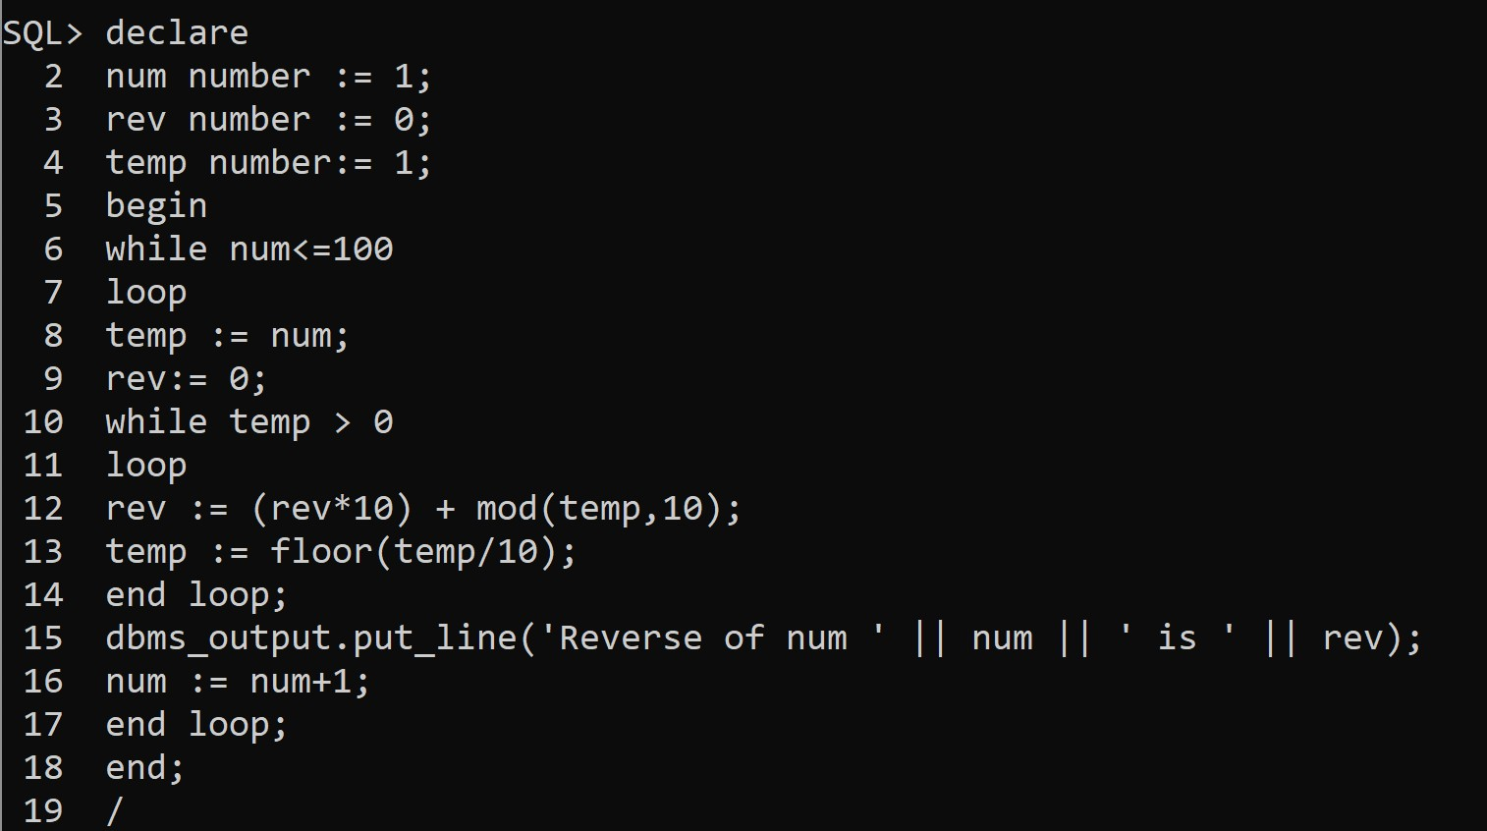

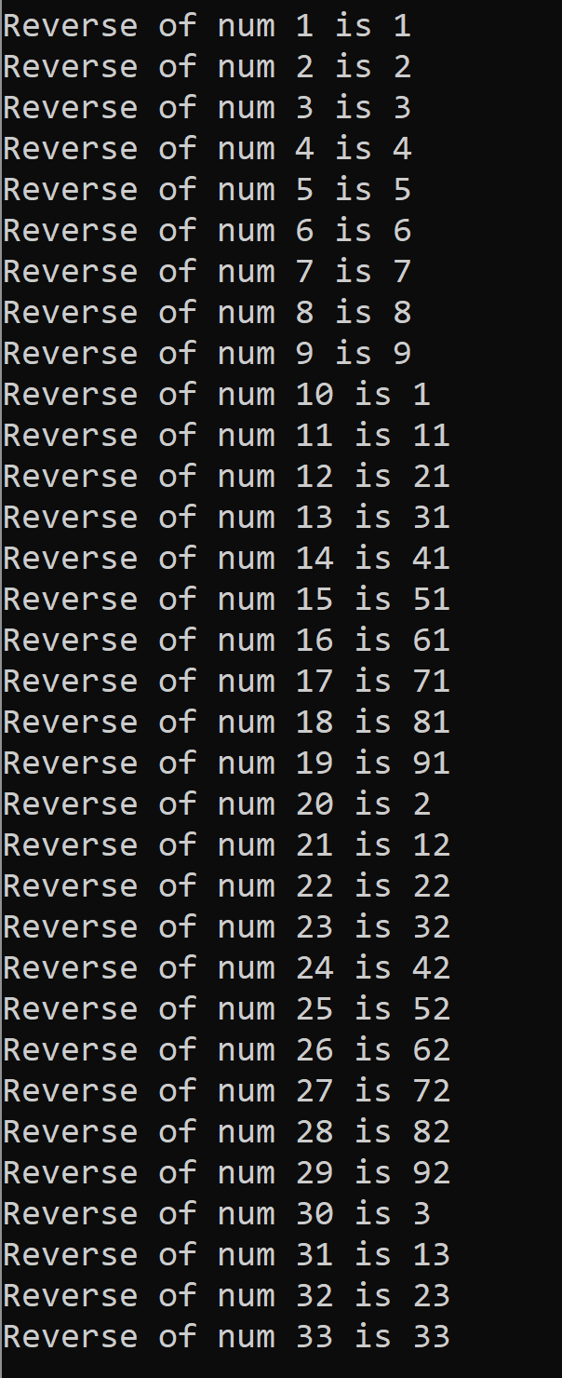

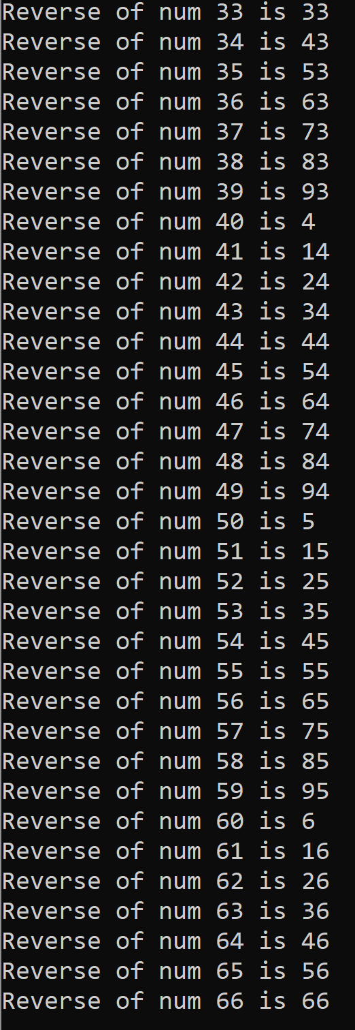

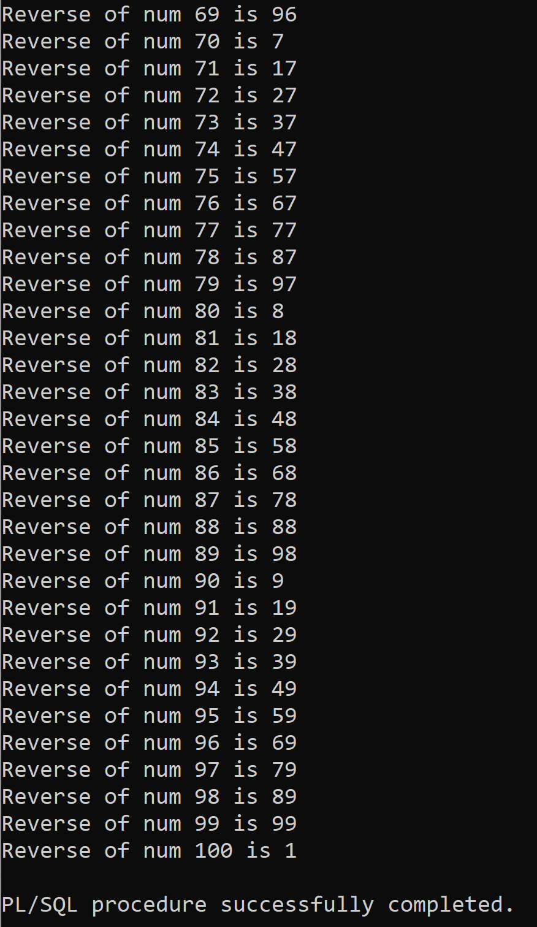

**Question 6:** Write a PL/SQL to reverse the given integer number.

# SQL Command:

declare

num number := 1; rev number := 0; temp number:= 1; begin

num := &num; temp := num; rev:= 0;

while temp > 0 loop

rev := (rev*10) + mod(temp,10); temp := floor(temp/10);

end loop;

dbms_output.put_line('Reverse of num ' || num || ' is ' || rev); num := num+1;

end;

# Output:

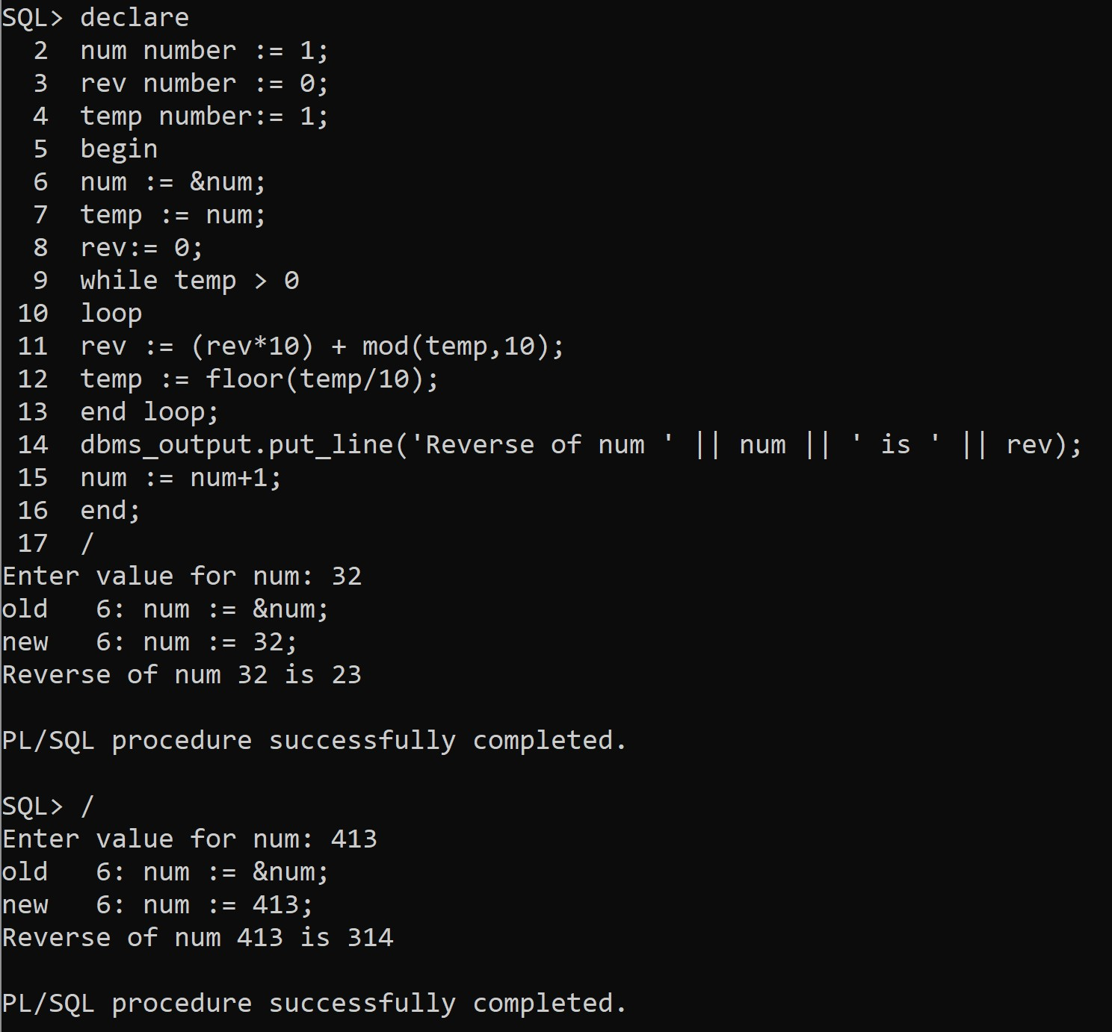

**Question 7:** Write a PL/SQL to display the number of employees for a given Department name.

# SQL Command:

declare

num_emp number := 0; department number; begin

department := &department;

select count(*) into num_emp from Employee where Department_Number = department;

dbms_output.put_line('The number of employees in department '

|| department || ' are ' || num_emp); end;

# Output:

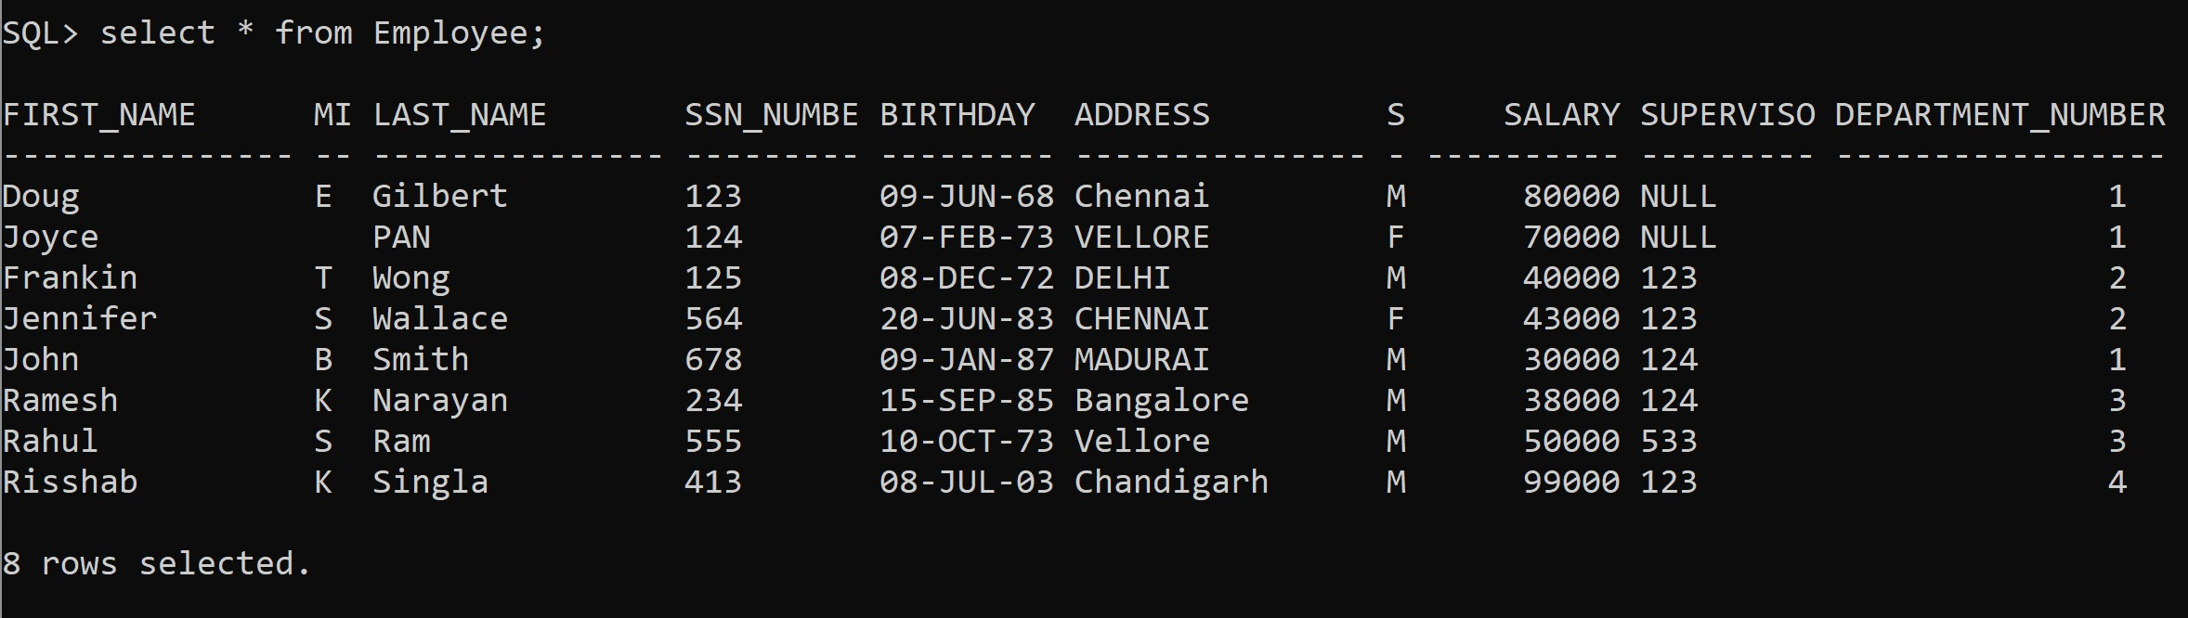

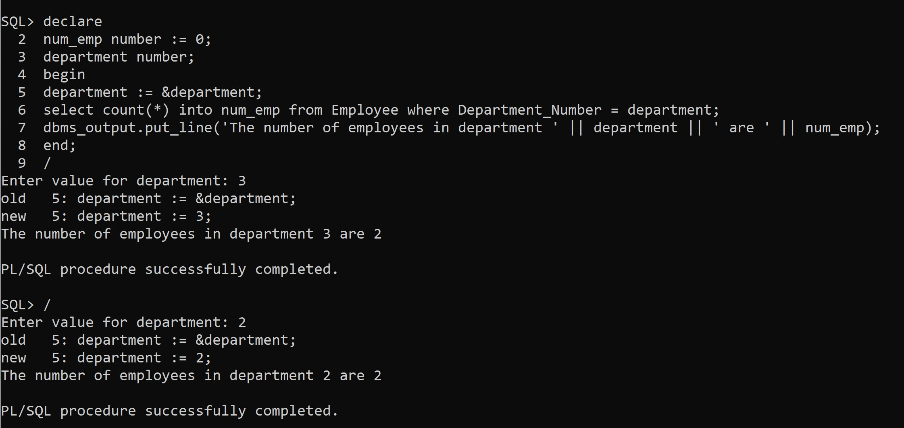

**Question 8:** Write a PL/SQL to accept an employee name and display his department names

# SQL Command:

declare

F_Name Employee.First_Name%type;

Dep_name Department.Department_Name%type; Dep_number Department.Department_Number%type; begin

F_Name := '&F_Name';

select Department_Number into Dep_number from Employee where First_Name = F_Name;

select Department_Name into Dep_name from Department where Department_Number = Dep_number;

dbms_output.put_line('The Department for ' || F_name || ' is ' || Dep_name);

end;

# Output:

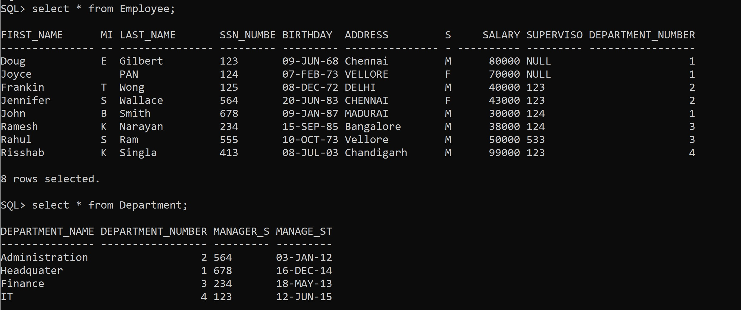

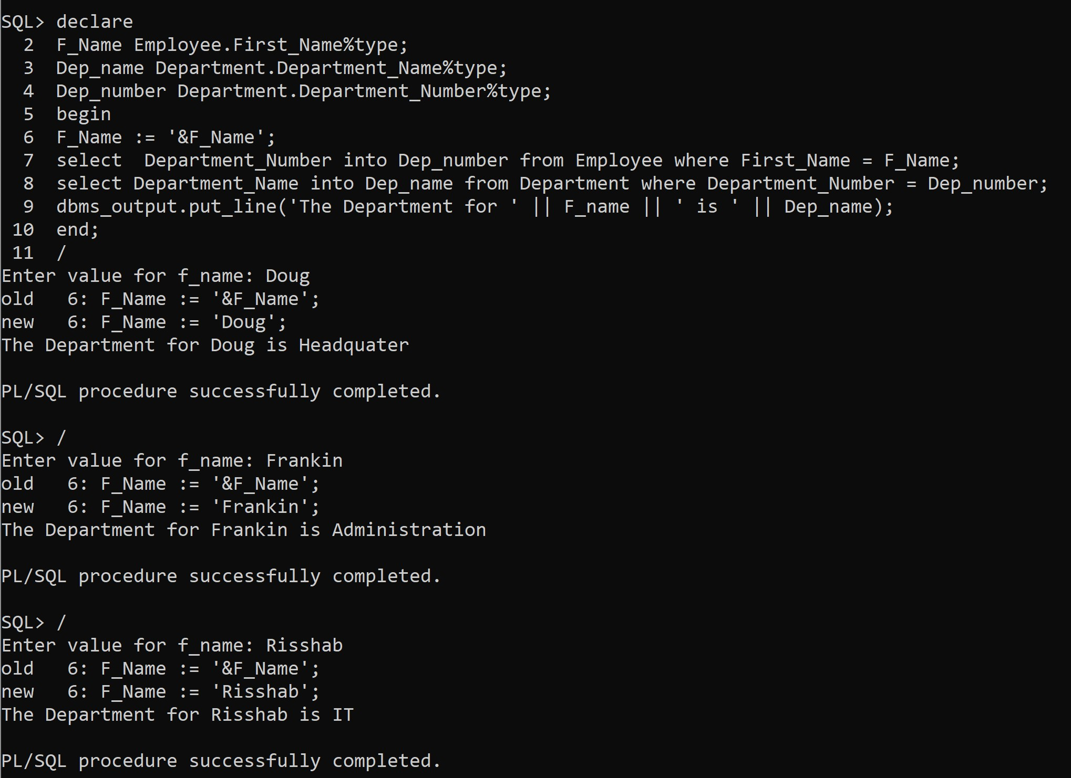

**Question 9:** Write a PL/SQL to print the employee’s name with salary of those employee names starting with letter ‘S’.

# SQL Command:

declare

v_sal Employee.Salary%type := 0; begin

select Salary into v_sal from Employee where First_Name like 'S%'; Exception

When No_Data_Found then v_sal := NULL;

if(v_sal is NULL) then

dbms_output.put_line('No Person found with Starting Letter S'); else

dbms_output.put_line(v_sal); end if;

end;

# Output:

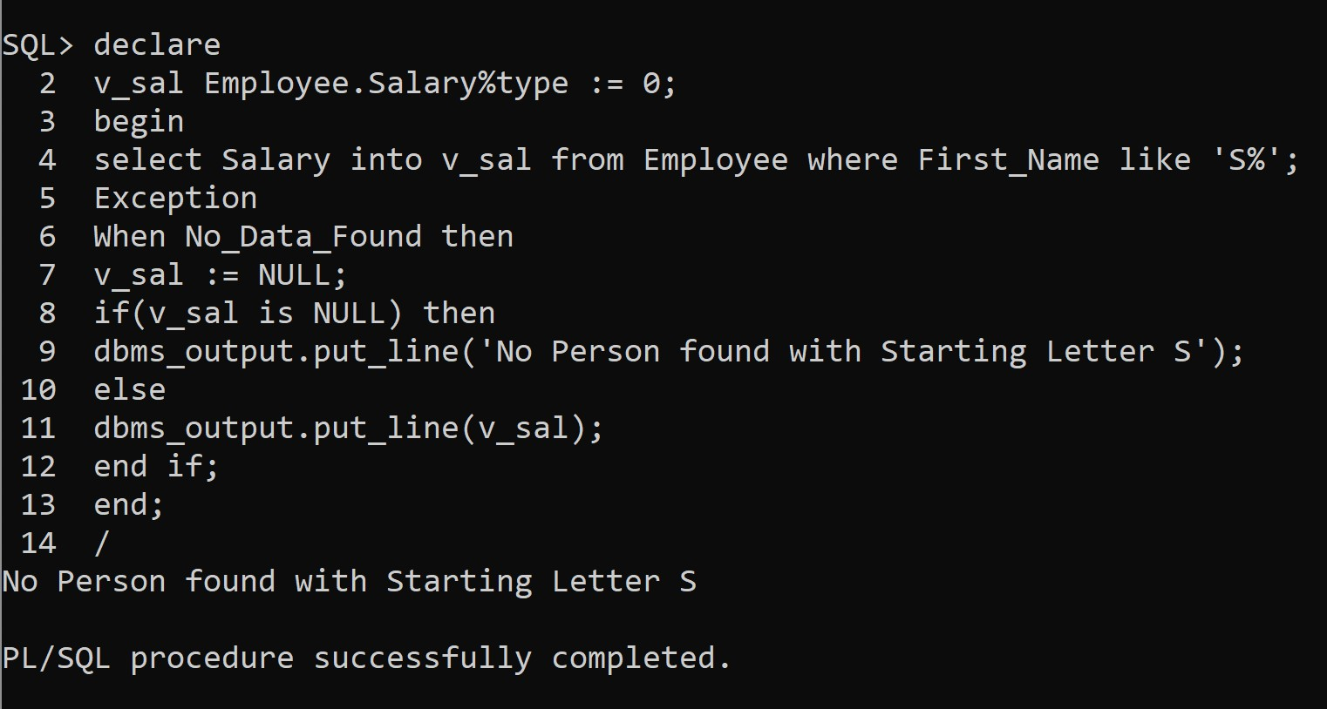

**Question 10:** Write a PL/SQL to find the number of employees who is getting salary greater than 10000.

# SQL Command:

declare

num number; begin

select count(*) into num from Employee where Salary > 10000; dbms_output.put_line('The number of employees with salary

>10000 are: ' || num); end;

# Output:

